[Insert Company Name/Logo]

Street Address, City, ST Postal Code​

​​Telephone​

​​Fax​

​​Email​

​​Website​

TO: **Manitoba Liquor and Lotteries Corp.**

Date: [Enter a date]

Re: **Letter of Authorization / Appointment of Exclusive Agent**

We hereby authorize the following to be our exclusive Agent with respect to the sale and marketing of the following products to Manitoba Liquor and Lotteries effective [***insert effective date***] and will be assigned to the entire brand line, including all package sizes and formats.

* Agents Name: ***[insert Agent/Agency Name]***
* Address: ***[insert Agent/Agency Address]***
* Phone Number ***[insert Agent/Agency Phone Number]***
* Email: ***[insert Agent/Agency Email address]***

**Description of Products:**

* [insert brand name or product line]
* [insert specific product names, Item numbers if applicable]
* [insert any additional details of individual products]

We authorize MBLL to make [*insert Supplier or Agent/Agency Name*] the payee for our products.

You are entitled to deal exclusively with our Agent. The appointment of this agent will continue until we notify you in writing of our termination of the agency.

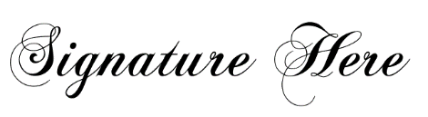

**[insert Contact Name]**

**[insert Job Title and/or Department]**

**[insert Company Name]**